Name: Weekly Math Review – Q2:3 Date:
Monday | Tuesday | Wednesday | Thursday
How many tens? ____  How many ones? ____  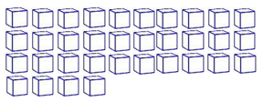  How many? ______ | What two numbers make 10?  3 + __ | How many tens? ____  How many ones? ____  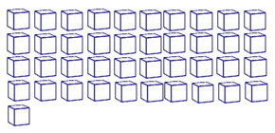  How many? ______ | What two numbers make 10?  __ + 8
Add the numbers.  2 + 5 = ___ | Kelly slid down the slide at the park 5 times. Jamie slid down 4 times. How many times did they slide altogether?  ____ + ____ = ____ | Subtract the numbers.  7 - 4 = ___ | Grace drew 4 rectangles. Then she erased 3 of them. How many rectangles are on her paper?  ____ - ____ = ____
Put the number cards in order from least to greatest.  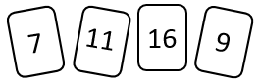  ____ ____ ____ ____ | Fill in the missing numbers on the number line.  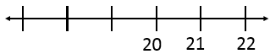 | Put the number cards in order from greatest to least.  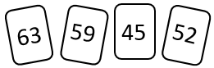  ____ ____ ____ ____ | Fill in the missing numbers.  28, ___, ___, 31, 32  ___, ___, 45, ___,
Which shape doesn’t belong? | Draw a shape with 2 long sides, 2 short sides, and cut it into 4 equal parts. | Draw a hexagon. How many sides? How many corners?  Sides _____ Corners_____ | Cut the rectangles into fourths.
Who is taller?  You  OR  Your teacher | Circle the shortest block.  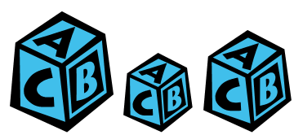 | Circle the tallest girl.   | Order the banans from shortest to longest.  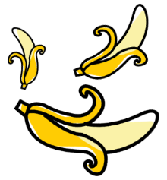
About how many paperclips long is the pencil?   | How many paperclips long is the crayon?   | How many cubes tall is the boy?  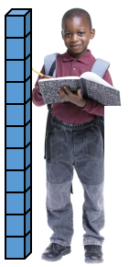 | How many cubes tall is the dog?  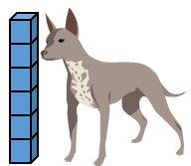
My Work
Monday | Tuesday
Wednesday | Thursday

My Progress
MONDAY  Out of _____ questions, I got ______ correct. | TUESDAY  Out of _____ questions, I got ______ correct. | WEDNESDAY  Out of _____ questions, I got ______ correct. | THURSDAY  Out of _____ questions, I got ______ correct.

Answer Key - Weekly Math Review – Q2:3
Monday | Tuesday | Wednesday | Thursday
How many tens? 3  How many ones? 4  How many? 34 | What two numbers make 10?  3 + 7 | How many tens? 4  How many ones? 1  How many? 41 | What two numbers make 10?  2 + 8
Add the numbers.  2 + 5 = 7 | Kelly slid down the slide at the park 5 times. Jamie slid down 4 times. How many times did they slide altogether?  5 + 4 = 9 | Subtract the numbers.  7 - 4 = 3 | Grace drew 4 rectangles. Then she erased 3 of them. How many rectangles are on her paper?  4 - 3 = 1
Put the number cards in order from least to greatest.  7, 9, 11, 16 | Fill in the missing numbers on the number line.  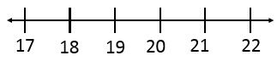 | Put the number cards in order from greatest to least.  63, 59, 52, 45 | Fill in the missing numbers.  28, 29, 30, 31, 32  43, 44, 45, 46
Which shape doesn’t belong? | Draw a shape with 2 long sides, 2 short sides, and cut it into 4 equal parts. | Draw a hexagon. How many sides? How many corners?  Sides 6 Corners 6 | Cut the rectangles into fourths.
Who is taller?  You  OR  Your teacher | Circle the shortest block. | Circle the tallest girl. | Order the bananas from shortest to longest.  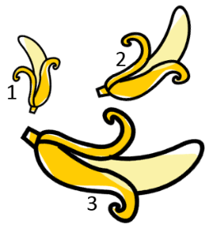
About how many paperclips long is the pencil?  5 | How many paperclips long is the crayon?  2 | How many cubes tall is the boy? 11 | How many cubes tall is the dog? 6

